All info for this will be found: https://tutorial.djangogirls.org/en/installation/

>py -to check python version you have

>>> quit() -to cancel out

>dir -to access directory

>cd Documents -change directory to Documents

>mkdir myProjects -create a directory for your projects

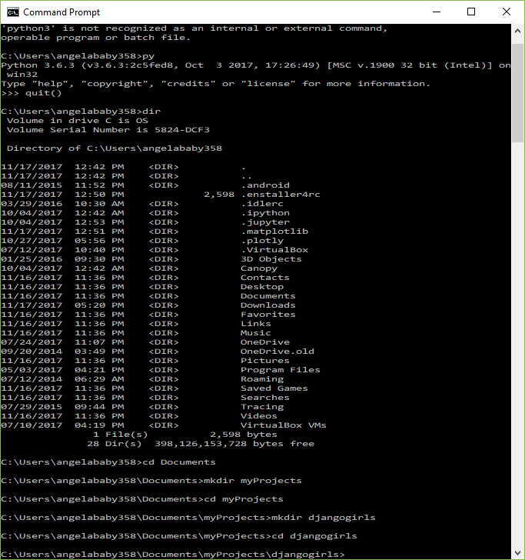

* Install the virtual environment myvenv
* To start virtual environment

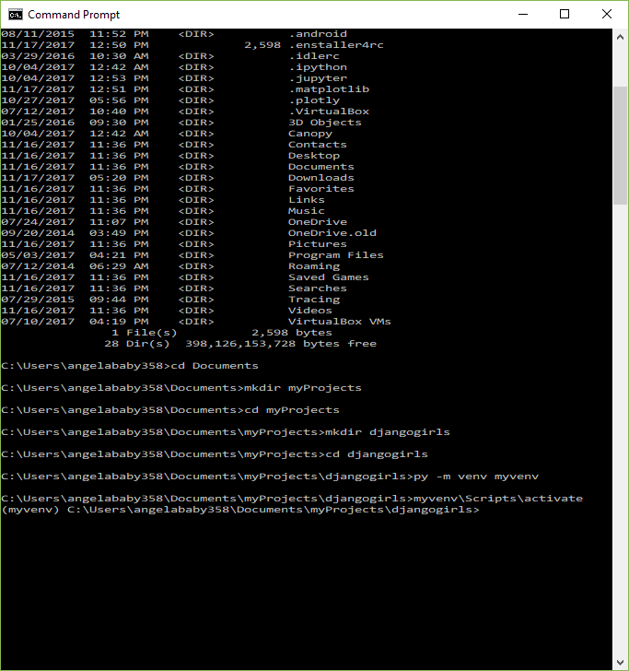

(myvenv)….. pip install --upgrade pip

(myvenv)….. pip install django~=1.11.0 - to install django 😊